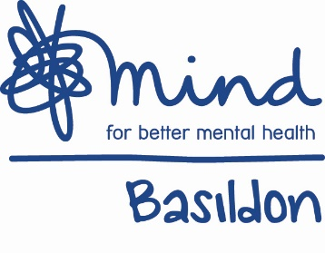
BASILDON MIND

VOLUNTEERS APPLICATION FORM
CONFIDENTIAL

Personal Details:

Title (Mr, Mrs, Ms, Dr etc):

Surname:

Forenames:

Permanent Address:
(inc. Postcode)

Telephone No.:

Work Telephone No.:

Mobile No.:

Email (optional):

Education, Professional Qualifications and Other Training:

‘O’ Levels or equivalent:

‘A’ Levels or equivalent:

Degree or equivalent:

Professional qualifications:

Training:

Please give brief details of current full/part-time, paid/unpaid and/or any voluntary
work you are doing:

References:

Please give the names and addresses of two referees who are able to provide details of your
suitability for voluntary work with Basildon Mind.

First Referee

Name:

Organisation:

Position:

Address:

Telephone no.:

Email:

Second Referee

Name:

Organisation:

Position:

Address:

Telephone no.:

Email:

Criminal Convictions:

Rehabilitation of Offenders Act 1974 (Exceptions Order 1975)

Have you ever been convicted of a criminal offence? Yes/No (please delete as applicable)

If Yes, please give particulars. Because of the nature of the work for which you will be
involved, you must provide information about convictions under the provision of the
Rehabilitation of Offenders Act 1974. In the event of being accepted by Basildon Mind any
failure to disclose such conviction could result in your being asked to leave. Any such
information given will be treated in complete confidence.

I agree to disclose information as requested: Signed

I do not agree to disclose the information requested: Signed

Date | Place | Type of offence | Outcome

DBS Check:

It is Basildon Mind’s policy that all staff and some volunteers are required to complete a Disclosure and Barring Service Application Form.

Do you agree to comply with this policy? Yes/No (please delete as applicable)

Declaration

To the best of my knowledge the information I have given on this Application Form is correct. I understand that the provision of false information may result in disqualification or the termination of voluntary work.

Signed: Dated:

If you have any queries regarding this application form, please do not hesitate to contact the Volunteers Coordinator on 01268 289700.

Please return your completed Application Form to:
Jill Foley
Volunteers Coordinator
Basildon Mind
37 East Walk
Basildon, Essex
SS14 1HA

